|  |  |  |
| --- | --- | --- |
|  | **JSPM’s**  **RAJARSHI SHAHU COLLEGE OF ENGINEERING**  **TATHAWADE, PUNE-33**  **(An Autonomous Institute Affiliated to SavitribaiPhule Pune University,Pune)** |  |

1. **Statement of Clear Goal, Use of appropriate methods, Significance of results, Effective presentation**

**Name of the Course:** Artificial Intelligence

**Name of the Faculty:** Dr. Dipali H.Patil

**Name of the Innovative Method used:** NPTEL Video

**Name of the topic:** Searching Techniques in AI

**Statement of Clear Goal**: To help students understand topics better by using NPTEL videos in teaching, so they can learn anytime, review difficult concepts, and enjoy learning through visual content.

**Significance of result:** After watching the video, students were able to understand the topic more clearly, remember key points better, and showed improved participation and performance in related activities assessments.

**Effective (Screenshot):**

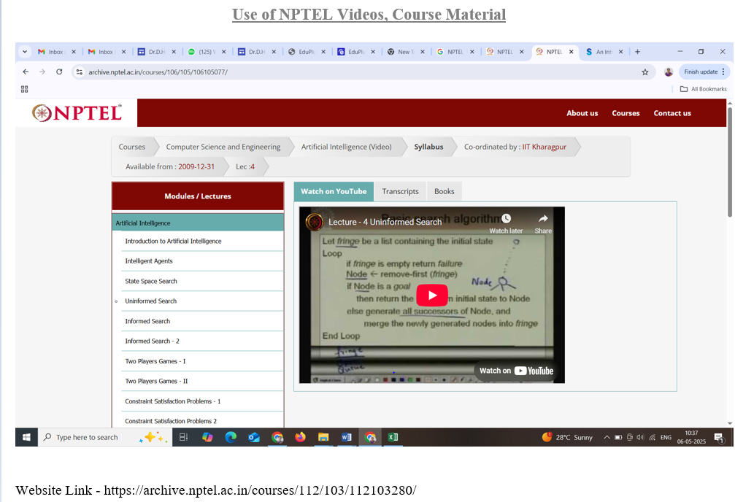

**Peer Review and Critique (Feedback):** Comments of videos

Website link: https://archive.nptel.ac.in/courses/112/103/112103280/

1. **Availability of work related to Innovation by Faculty in Teaching and Learning is on Institute website.**

[**https://www.jspmrscoe.edu.in/information-technology/innovation-practices**](https://www.jspmrscoe.edu.in/information-technology/innovation-practices)

1. **Availability of work for peer review and critique.**

[**https://github.com/jspmIt/DHP**](https://github.com/jspmIt/DHP)

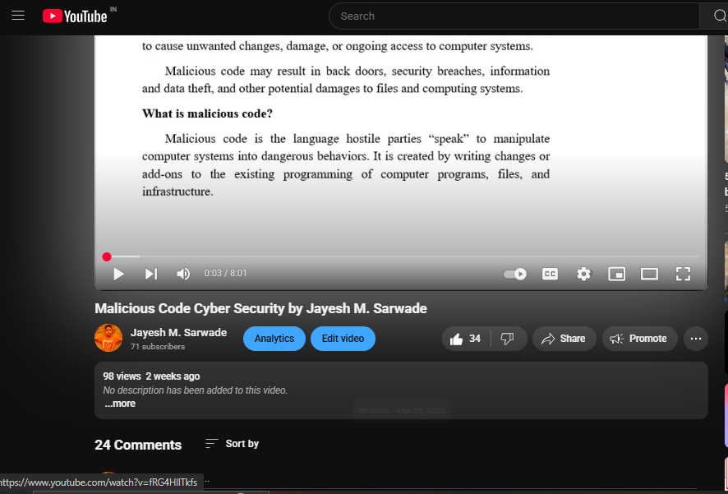

**D: Reproducibility and Reusability by other scholars for further development**

* Students are engaging with and potentially applying the content.
* All course materials including lecture scripts, slides, datasets, source code, and references should be well-documented and stored in an accessible format

|  |  |  |  |
| --- | --- | --- | --- |
| **Sr.No** | **Innovation Used by** | **Details of User** | **Purpose of**  **Reproducibility and Reusability** |
| **1.** | **Use of NPTEL videos** | **Dr. Dipali Patil** | NPTEL videos should be developed with reproducibility in mind, enabling learners and educators to reliably replicate demonstrated concepts or experiments. This not only validates the instructional content but also cultivates a culture of openness and scholarly cooperation. |
|  |  |  |  |

**Course Co-ordinator Module Co-coordinator HOD**

Dr. Dipali H.Patil Dr. D.T.Salunke Dr. Nihar M. Ranjan